Pregnancy diagnosis in animals
Several methods are available to determine if a cow pregnant.
- Non-return to oestrus
If oestrus signs are not observed around 3 weeks after service or insemination, the cow is generally assumed to be pregnant. However, even if oestrus detection is good, not all of these cows will be pregnant. On the other hand, up to 7% of pregnant cows will show some signs of oestrus during pregnancy. Insemination of these animals may result in embryonic or foetal death.
- Rectal palpation
Advantage: immediate result enabling early diagnosis of non-pregnant cattle.
Accuracy: depends on the experience of the practitioner and can reach 95%.
Rectal examination is usually carried done between 35 and 65 days post AI.
Early pregnancy diagnosis
(1-3 months)
Based on a combination of the following:
- asymmetry of the uterine horns
- decrease in the tone of the pregnant horn
- fluctuant contents in the pregnant horn (later both horns)
- a palpable corpus luteum on the ovary on the same side as the pregnant horn
- membrane slip
- appreciation of an amniotic vesicle.
Diagnosis in later pregnancy
(>3 months)
- cervix is located anterior to the pelvic rim and the uterus cannot be retracted .
- uterus is flaccid .
- placentomes, and sometimes the foetus, are palpable .
- the median uterine artery increases in diameter and fremitus can be detected.
Common reasons for errors in rectal palpation
- failure to retract the uterus .
- abnormal uterine contents (pyometra or mucometra) .
- incorrect service dates.

Safety
Rectal palpation is widely used and considered a safe method for pregnancy diagnosis in cattle. Nonetheless early or inappropriate palpation of the amniotic vesicle may damage the embryo and cause embryonic mortality.
- Hormone measurements
Progesterone assay
The progesterone secreted by a functional corpus luteum between 18 and 24 days after service or insemination is an early indication of pregnancy. It can be assayed in milk or plasma. Optimal assay time is 24 days after mating or AI, this eliminates the possibility of long oestrus intervals which might result in false positives.
Common reasons for errors in hormone measurements
- pyometra/persistent corpus luteum
- short oestrus intervals
- cystic ovarian disease (luteal cysts)
- incorrect handling of the samples and test kit
- Early Pregnancy-associated Protein
Recently available tests detect so called early conception factor (ECF) or pregnancy-associated glycoprotein in blood samples. They are reported to detect the pregnancy-associated glycoprotein within 48 hours of conception.
Because of the high incidence of embryonic mortality this test should be treated solely as an indication of conception. Pregnancy should be confirmed later by rectal or ultrasound examination.
- Ultrasound examination
Real time (B-mode) ultrasound is a reliable and relatively simple method of diagnosing pregnancy as early as day 26.
Accuracy
An accuracy of over 99% can be achieved, enabling fertility problems to be identified rapidly. The main advantage of scanning is that it can give an accurate diagnosis earlier than rectal palpation.
Early pregnancy diagnosis and embryonic loss
Pregnancy can be detected earlier with ultrasound compared with rectal palpation. The rate of detection of early embryonic loss is thus also higher.
10 to 16% of cows diagnosed pregnant at 28 days post AI, experience early embryonic loss by 56 days post AI. Cows diagnosed pregnant at 28 days post AI using ultrasound should be scheduled for a subsequent examination around 60 days post AI, when the rate of embryonic loss per day decreases dramati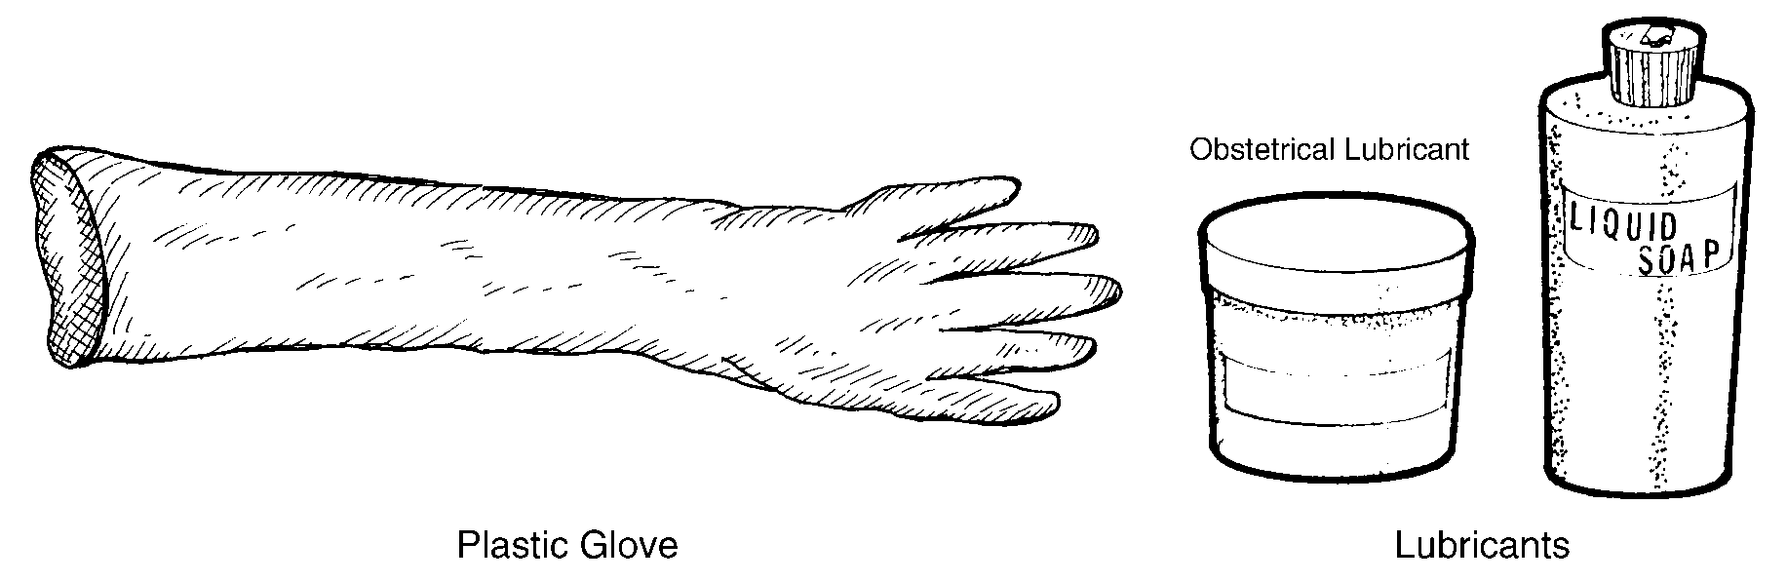cally.sbre

